# Task 1

1. Create the database named "HMBank"

2. Define the schema for the Customers, Accounts, and Transactions tables based on the provided schema.

Output:

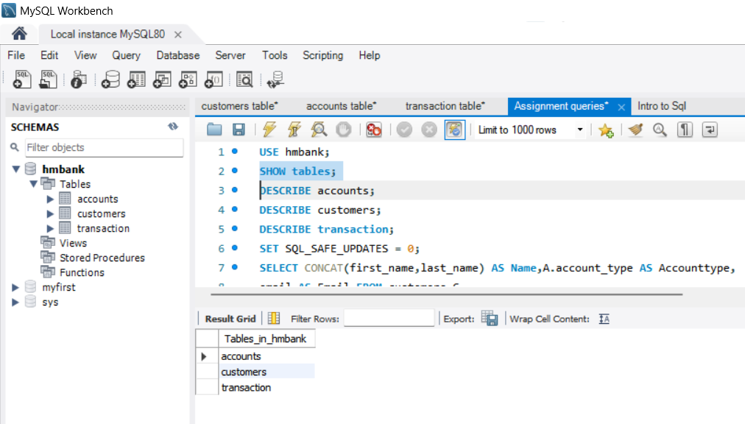

1. Create an ERD (Entity Relationship Diagram) for the database.

Output:

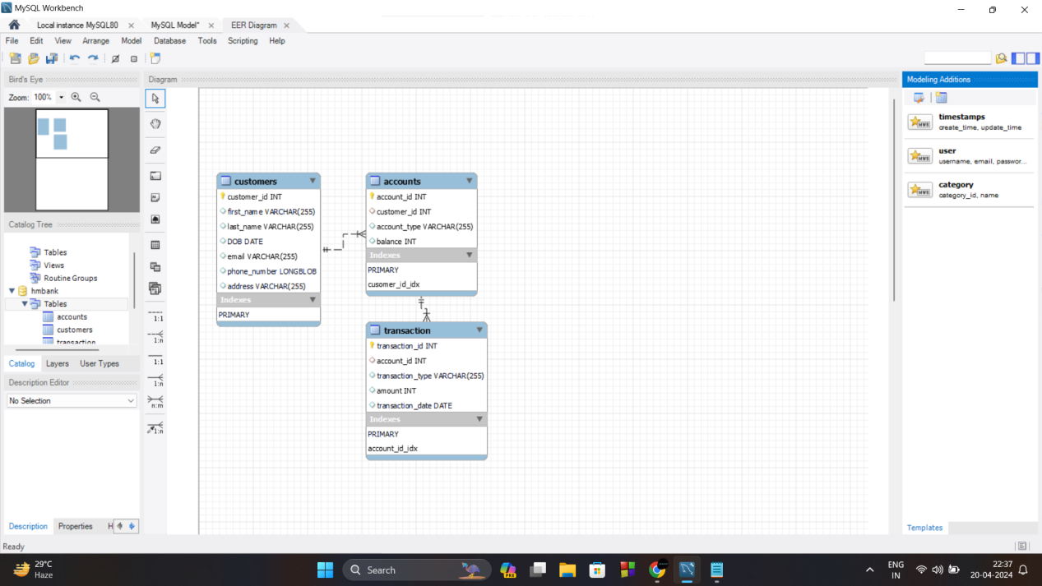

1. Create appropriate Primary Key and Foreign Key constraints for referential integrity.

Output:

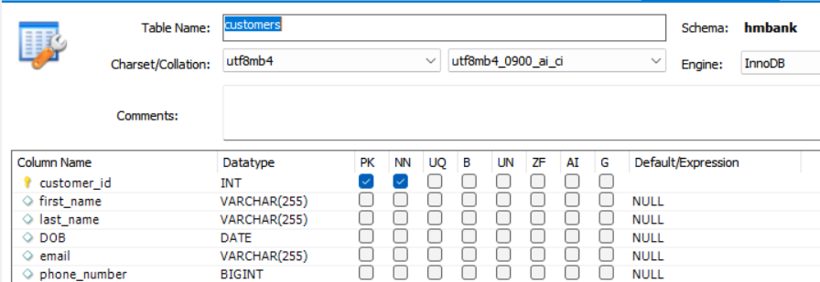

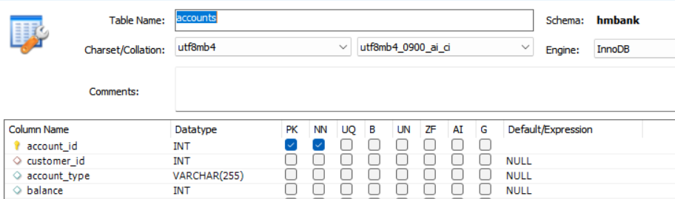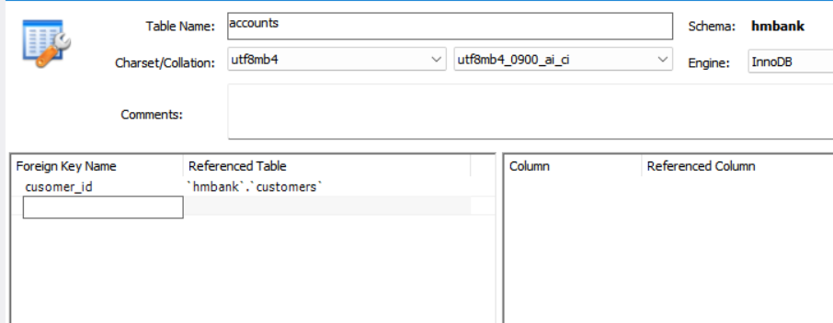

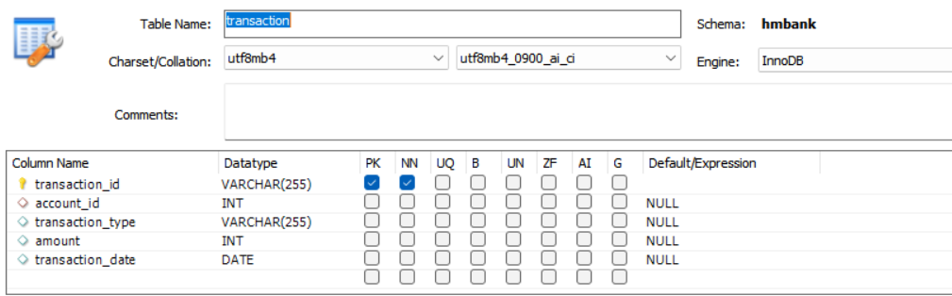

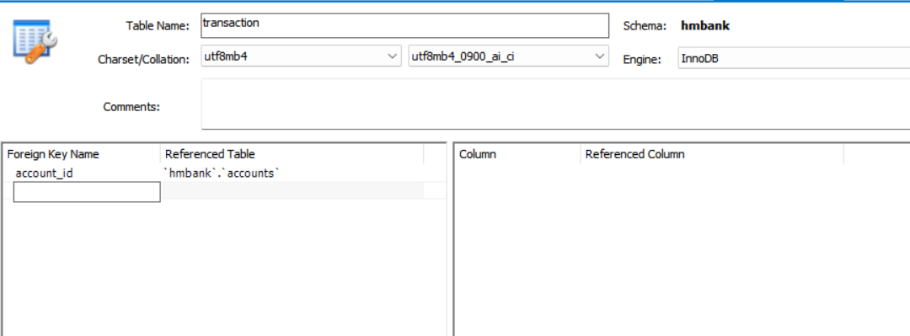

5. Write SQL scripts to create the mentioned tables with appropriate data types, constraints, and relationships.

• Customers • Accounts • Transactions

Output:

CREATE TABLE Customers ( customer_id INT , first_name VARCHAR(255), last_name VARCHAR(255), DOB DATE, email VARCHAR(255), phone_number VARCHAR(255), address VARCHAR(255), PRIMARY KEY (customer_id) );

CREATE TABLE Accounts ( account_id INT , customer_id INT, account_type VARCHAR(255), balance DECIMAL(10, 2), PRIMARY KEY (account_id), FOREIGN KEY (customer_id) REFERENCES Customers(customer_id) );

CREATE TABLE Transactions ( transaction_id INT , account_id INT, transaction_type VARCHAR(255), amount DECIMAL(10, 2), transaction_date DATETIME, PRIMARY KEY (transaction_id), FOREIGN KEY (account_id) REFERENCES Accounts(account_id) );